BMI Calculator
Project Report

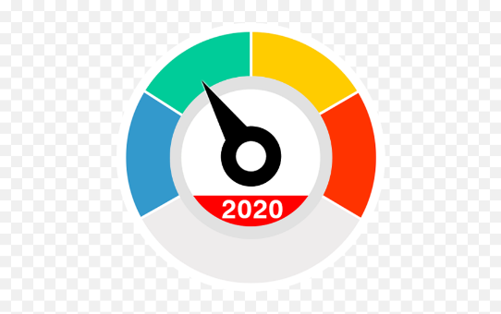
Name: Irene Jino
Reg No: 25BOE10004

Introduction
This project implements a simple Body Mass Index (BMI) Calculator using Python. The BMI is a widely used measure to assess whether an individual has a healthy body weight for their height. The program interacts with the user to collect necessary inputs, performs the BMI calculation, and then provides a categorical assessment of the user's weight status based on established health guidelines.

Problem Statement
The current healthcare system requires quick, automated tools for preliminary patient assessment. The problem is to develop a robust and error-resistant computational tool that accepts a user's standard physical metrics (height in cm, weight in kg) and performs a physiologically accurate calculation of Body Mass Index (BMI). The primary objective is not just to output the raw number, but to categorize the individual's result against globally accepted weight status standards (Underweight, Healthy/Normal, Overweight, and Obese) to provide an immediate, actionable health risk indicator. This tool must correctly handle data types and ensure that the conditional logic for classification uses non-overlapping, mutually exclusive ranges to prevent misdiagnosis.

Functional Requirements
1. Input & Preparation
​FR1.1: Prompt and accept Height (cm) as a float.
​FR1.2: Convert Height from cm to meters ({height}/100).
​FR1.3: Prompt and accept Weight (kg) as a float.
2. Processing & Output
​FR2.1: Calculate BMI using the formula: {Weight} / {Height} times {Height}).
3. Classification Logic (Based on Provided Code)
​FR3.1: If {BMI} <= 18.5: Output 'You are underweight'.
​FR3.2: Else if {BMI} >=24.9: Output 'You are healthy'.
​FR3.3: Else if {BMI} >=29.9: Output 'You are overweight'.
​FR3.4: Otherwise (Else block): Output 'You are obese'.
​FR2.2: Display the calculated BMI value.

Non-Functional Requirements
- Performance (NFR 1.1): The calculation and display must complete in less than 1 second.
- ​Usability (NFR 2.1): Input prompts and output messages must be clear and unambiguous.
- ​Reliability (NFR 3.1): Identical inputs must consistently produce the same BMI and classification.
- ​Maintainability (NFR 4.1): Code must be well-structured with meaningful variable names.
- ​Portability (NFR 5.1): Application must run on any platform with a Python interpreter

System Architecture
I. Input
Role: Gathers necessary data from the user.
Data: Height (in cm), Weight (in kg)
Action: Converts string inputs to floats for calculation.
II. Processing
Role: Performs calculations and applies classification logic.
Steps: Conversion: Converts \text {height (cm)} to \text {height (meters)} by dividing by 100.
Calculation: Computes BMI using the formula: BMI = \frac{weight}{height^2}.
Classification: Uses if/Elif/else logic to categorize the BMI result into: Underweight (BMI <= 18.5)
Healthy (BMI >= 24.9)
Overweight (BMI >= 29.9)
Obese (Catch-all else)
III. Output:
Role: Displays the results to the user.
Result: The calculated BMI value.
The corresponding health category.
Design Diagrams
Use Case Diagram
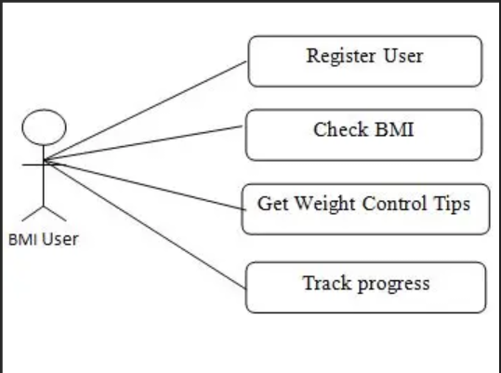
Workflow Diagram
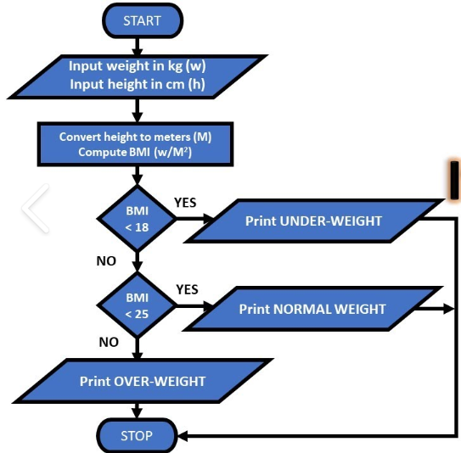

Class Diagram
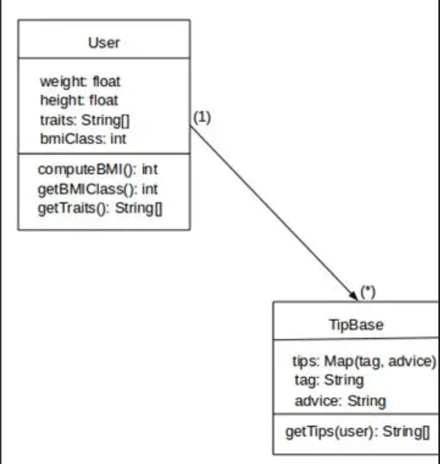
Sequence Diagram
Participant | Message
User | Start Program
System | Displays: "===BMI Calculator==="
System | Request: "Enter your height cm: /n"
User | Input Height (e.g., 175)
System | Processes: height = 175 / 100 (Converts to meters)
System | Request: "Enter your weight kg: /n"
User | Input Weight (e.g., 70)
System | Processes: Calculates $BMI = 70 / (1.75 \times 1.75)$
System | Output: "Your body mass index (BMI) is {BMI_Value}"
System | Decision: Check if (BMI <= 18.5)
System | If (BMI<=18.5): Output: "You are underweight"
System | Check if BMI >= 24.9)
System | If True: Output: "You are healthy"
System | Else, check if BMI >= 29.9)
System | If True: Output: "You are overweight"
System | Else: Output: "You are obese"
System | End Program

Design Decisions and Rationale
Decision | Rationale
Input Units (cm, kg) | Metric standard for BMI; user-friendly input.
Internal Conversion | Satisfies formula requirement (height in meters) while keeping user input simple (cm - m).
Use of float () | Ensures precision and accurate arithmetic for decimal inputs/results.

Decision | Rationale
Direct BMI Formula | Simple, single-step implementation of {weight} / {height}^2.
if-Elif-else | Standard, mutually exclusive structure for categorization
Category Output | Immediate user understanding through human-readable strings (e.g., "You are healthy").

Decision | Rationale
Use of print () | Native and simplest I/O for a command-line application.
f-strings | Clean and efficient way to embed the BMI variable into the output message.

Implementation Details
1. Input
Uses input () and float () to get Height (cm) and Weight (kg).
Converts: height is divided by 100(cm- m).

2. Process
Calculates BMI: {BMI} = {weight} / height} ^2.
Classifies: Uses a sequential if-Elif-else block to assign a health category based on the calculated BMI thresholds.

3. Output
Uses print () and f-strings to display the final calculated BMI value and the corresponding category to the console.

Screenshots/Results
Code
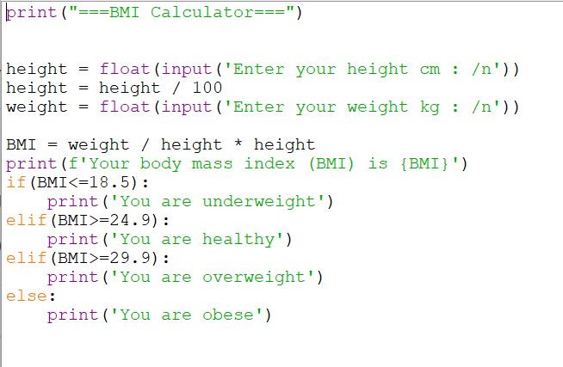

Output
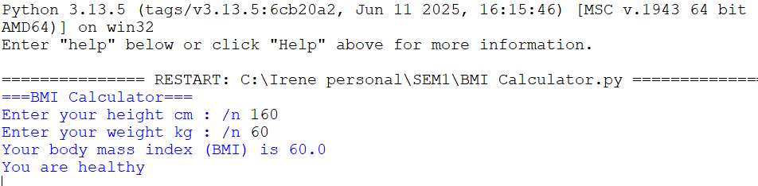
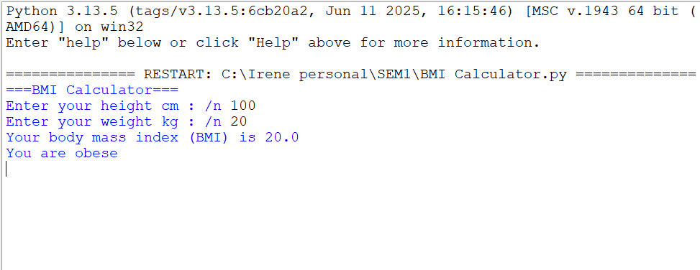
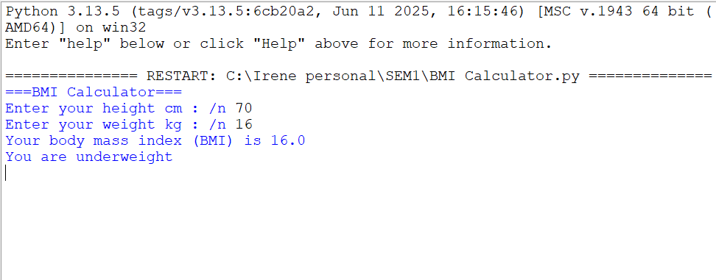

Testing Approach
The strategy is Black Box Testing, using two main techniques focused on the classification logic:
- Boundary Value Analysis (BVA): Test inputs exactly at and near the fixed BMI thresholds (18.5, 24.9, 29.9).

- Equivalence Partitioning (EP): Test representative values within each of the four categories (Underweight, Healthy, Overweight, Obese).

Challenges Faced

- Formula Accuracy: Ensuring correct calculation of {weight} / {height}^2 by using parentheses (e.g., weight / (height * height)).
- ​Unit Conversion: Reliably converting inputs (e.g., {lbs} to {kg}, {cm} to {m}) to meet the formula's requirements.
- ​Input Validation: Handling non-numeric, negative, or zero inputs gracefully to prevent system crashes.
- Logical Flaws: Designing the if/Elif/else structure to create mutually exclusive (non-overlapping) and exhaustive (no gaps) classification ranges.
- ​Standard Adherence: Using the correct, medically accepted thresholds (e.g., 18.5, 24.9) for Underweight, Healthy, Overweight, and Obese categories.

Learnings and Key Takeaways
The key lessons from the BMI calculator project boil down to three essential areas: correctness, logic, and design.
​1. Correctness in Code and Units
​Mathematical Precision: The primary technical takeaway is that code must accurately reflect the mathematical formula. Operator precedence is critical; ensure the calculation is {BMI} = {weight} / {height} * {height}) using parentheses.

2. Robust Conditional Logic
​Mutually Exclusive Ranges: The logic flow (if-Elif-else) for classification must be structured to check sequential, non-overlapping ranges. This avoids misclassification (like assigning 'Obese' to the 'Healthy' range) and ensures every value falls into only one correct category.

- Future-Proof Design
​Requirement Focus: Defining clear Functional and Non-Functional Requirements (NFRs) helps guide development and sets standards for usability and reliability.

Future Enhancements
Robustness and Error Handling
These enhancements address the code's current fragility:
- Input Validation Loops: Implement while loops and try-except blocks to prevent crashes on invalid input (non-numeric, zero, or negative values). The system should re-prompt the user until valid data is entered.
- Zero Division Guard: Explicitly check if the calculated height in meters is zero before performing the division to prevent a Zero Division Error.

User Experience Enhancements
These changes make the tool more flexible and helpful for users:
- Unit Selection: Allow the user to choose between Metric (kg/cm) and Imperial (lbs/in) systems. The system would then handle the necessary unit conversions internally before applying the BMI formula.
- Result Persistence: Implement a simple feature to log previous calculations (e.g., save the date, height, weight, and BMI result to a CSV file or a simple text file).

References

- Simple BMI calculator with step-by-step explanation, using a function that takes height and weight inputs and returns the BMI rounded to 2 decimals:
https://www.datainsightonline.com/post/simple-bmi-calculator-using-python​
- Another clear tutorial with BMI calculation and user input validation, showing conditional health status messages based on BMI ranges:
https://www.askpython.com/python/examples/bmi-calculator
- Beginner-friendly tutorial to build a BMI calculator in Python converting height from cm to meters and printing BMI categories:
https://dev.to/mindninjax/how-to-build-a-bmi-calculator-in-python-4g2g

